
Pay for Performance Program
Existing Buildings

Energy Reduction Plan

<ENTER PROJECT NAME>
<List Facility Address(es)>

<Insert Aerial Picture of Building>

Prepared For: <Enter Customer Company>
Prepared By: <Enter P4P Partner’s Company>

Application Number: <Enter P4P Application Number>
Date: <Enter Date>

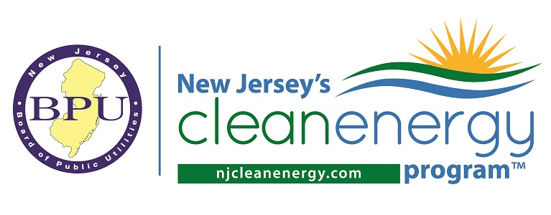
Table of Contents
EXECUTIVE SUMMARY 1
PROJECT OVERVIEW 6
Customer and Site Overview 6
Project Team 6
RECOMMENDED MEASURES 7
FUNDING & IMPLEMENTATION SCHEDULE 10

List of Tables
Table 1. Summary of Project Performance 1
Table 2. Summary of Program Incentives 5
Table 3. Measure Details 7
Table 4. Measure-Level Savings and Economics 8
Table 5. Measures Evaluated, Not Recommended 9
Table 6. Project Funding 10
Table 7. Implementation Schedule 10

List of Appendices
Appendix A: EPA ENERGY STAR Portfolio Manager®
Appendix B: Existing Equipment List

EXECUTIVE SUMMARY
In connection with New Jersey’s Clean Energy Pay for Performance Program (P4P), this Energy Reduction Plan (ERP) presents the findings of a comprehensive assessment which evaluated potential energy saving measures for <Enter Project’s Name> at <Enter Project Address>. This ERP details specific steps to be taken by the project owner to reduce energy cost and qualify for P4P incentives. This ERP is prepared in accordance with version X.X of the Pay for Performance Partner Guidelines.

The project was also evaluated using the US EPA’s ENERGY STAR Portfolio Manager® benchmarking tool to examine current energy consumption relative to similar facilities prior to implementation of recommended measures. Portfolio Manager results can be found in Appendix A.

Table 1 summarizes the current energy consumption of the property based on utility bills from <mm/dd/yyyy> to <mm/dd/yyyy>, projected energy savings based on proposed scope of work, and project economics.

Table 1. Summary of Project Performance

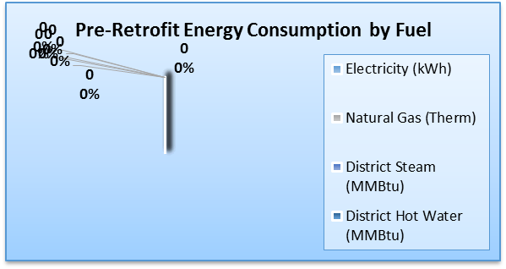
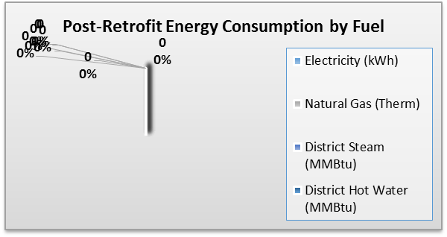
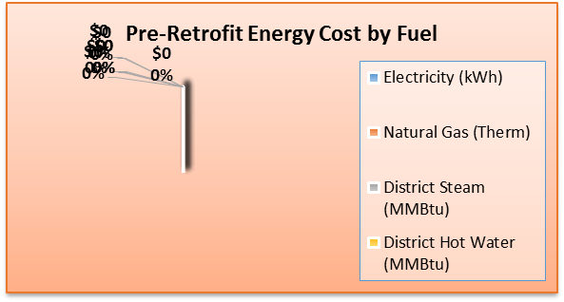
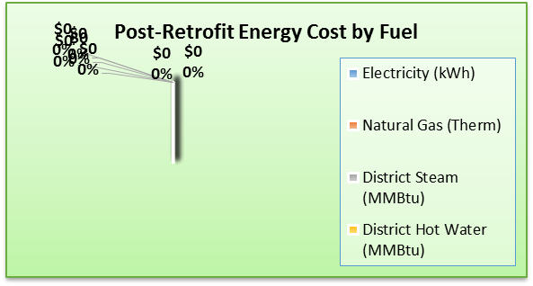
EXECUTIVE SUMMARY

EXECUTIVE SUMMARY

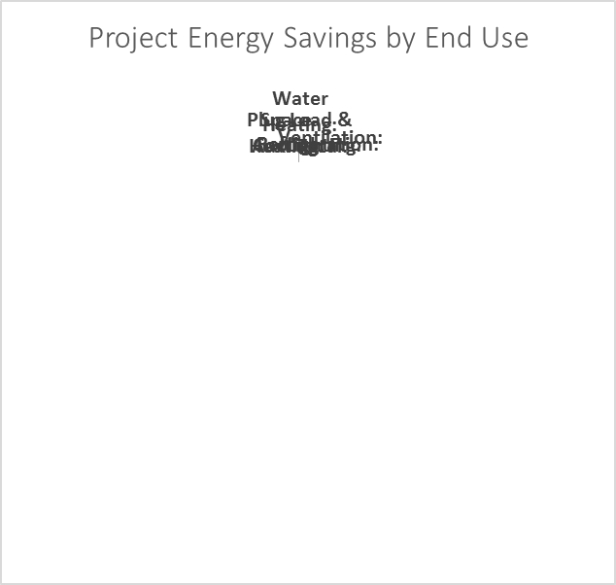
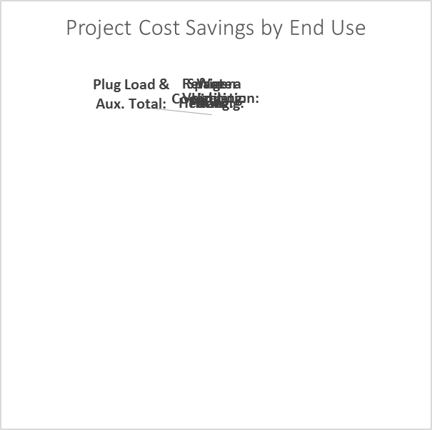

EXECUTIVE SUMMARY

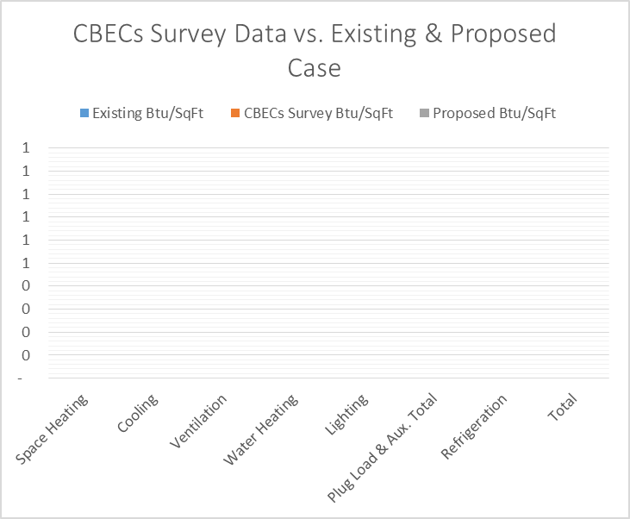

EXECUTIVE SUMMARY
Table 2 provides a summary of anticipated Program incentives. The first incentive is paid upon approval of the Energy Reduction Plan. The second incentive is paid upon installation of the recommended scope of work. Finally, the third incentive is paid twelve months post-installation upon verification of actual achieved savings.

Incentives #2 and #3 are designed as a single performance incentive that is split in order to provide up-front financial assistance in implementing the project. Incentive #3 will be “trued-up” based on actual achieved savings so that the total performance incentive (i.e. #2 and #3) is in compliance with the Program’s incentive structure. If savings are below the 15% minimum but at or above 5%, the project will still be eligible for an incentive, although at a reduced rate calculated at $0.005/kWh less and $0.05/therm less from the base incentive (i.e. $0.09/kWh and $0.90/therm) for each 1% savings below 15%. So long as the savings are at or above 5%, the minimum incentive paid is $10,000 or committed value, whichever is less, assuming all required data and documentation is submitted. If savings are less than 5% there will be no Incentive #3 paid. Incentives #1 and #2 are not required to be returned to the Program. The scaling down of incentives does not apply to high energy-intensity users, which are required to demonstrate at least 4% energy savings.

Table 2. Summary of Program Incentives

Customer and Site Overview

PROJECT OVERVIEW
<Enter Customer/Site Overview>

Date(s) Audit Completed: <Enter Audit Dates>

Project Team

RECOMMENDED MEASURES
This section describes the comprehensive energy efficiency opportunities assessed and recommended for this project in accordance with version X.X of the P4P Partner Guidelines. Table 3 provides measure details, Table 4 demonstrates measure-level savings and economics, and Table 5 lists measures evaluated but not recommended (for reference).

Table 3. Measure Details
RECOMMENDED MEASURES
Table 4. Measure-Level Savings and Economics

RECOMMENDED MEASURES
Table 5. Measures Evaluated, Not Recommended

FUNDING & IMPLEMENTATION SCHEDULE
Table 6 includes a description of the funding sources the Owner will use to finance implementation of the recommended measures. Table 7 shows the target implementation schedule for the recommended measures.

Table 6. Project Funding

Table 7. Implementation Schedule
APPENDIX A: EPA ENERGY STAR Portfolio Manager®
<Attach PDF of ENERGY STAR’s Portfolio Managers reports here, including Statement of Energy Performance (SEP), Data Verification Checklist, and Score Card (if applicable)>

APPENDIX B: Existing Equipment

<Attach PDF of ERP Excel Tables, Appendix B Tables (last tab) here>

