

New Jersey’s Clean Energy Program™
Higher Education Decarbonization Pilot
Decarbonization Plan Template
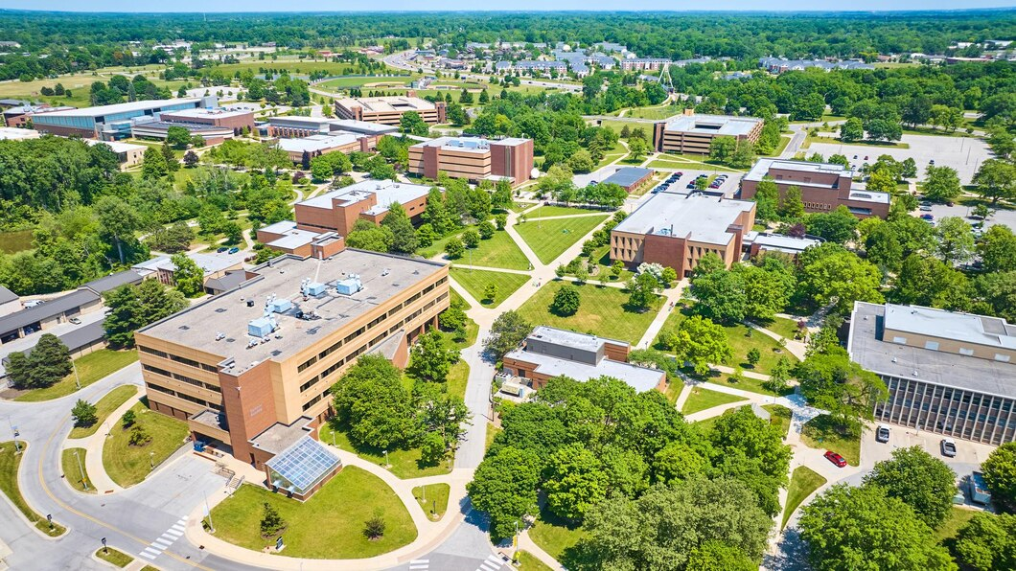

Plan Template Overview

Instructions
The template will assist in submitting the required documents and information for participation in the Higher Education Decarbonization Pilot. This outline may be integrated into a customer’s internal document format or completed within this document for submission of a DRAFT or FINAL decarbonization plan.
On the cover page, update customer information, identify whether the submission is a DRAFT or FINAL, and enter the submission date. Each revision to the plan should include an updated cover page with the submittal date and version number.
Section 7: Metering Plan and Appendices A through E are required for FINAL submittals only. Please include all appendices with each revision of the Final Decarbonization Plan.
Visit our website for complete program guidelines.

<College/University Name>
<Draft or Final> Decarbonization Plan
Rev <#>
<Date Submitted>
New Jersey’s Clean Energy Program™
Higher Education Decarbonization Pilot

Table of Contents
1 Executive Summary 5
2 Site Overview 7
3 Utilities Overview 8
4 Summary of Proposed Decarbonization Measures 9
5 Decarbonization Measure Descriptions 12
6 Financing Plan 13
7 Metering Plan 14
Appendix A: Professional Engineer (PE) Certification: 15
Appendix B: Utility Bills 15
Appendix C: Emissions Savings Calculations 16
Appendix D: Project Cost Documentation 16
Appendix E: Manufacturer’s Specification Sheets and Proof of Qualified Product Listing 17

Executive Summary
Instructions
The executive summary shall include a brief write-up summarizing the contents of the report and project team. The following summary table formats may be used to complete this task.

Contact Information
<College/University>  Main Point of Contact | <text here>
<Report Developer> | <text here>
<Other contacts as applicable> | <text here>
Table 1.1: Contact Information

 | Annual Consumption | Projected Savings | % Savings
Electricity (kWh) | 0 | 0 | 0%
Electricity (kW) | 0 | 0 | 0%
Natural Gas (Therm) | 0 | 0 | 0%
Other (Therm) | 0 | 0 | 0%
CO2e emissions | 0 | 0 | 0%
Co2e Intensity (Co2e/ft2) | 0 | 0 | 0%
Table 1.2: Project Summary

Total Project Cost ($) | $0
Annual Cost Savings ($) | $0
Internal Rate of Return (IRR) | 0%
Simple Payback (yrs) | 0
Table 1.3: Project Summary Costs & Savings Estimate

Site Overview
Instructions
The site overview section shall include, but is not limited to, the following information for the campus buildings:
- Name and address
- Short description and use
- Year built
- Square footage
The following summary table format may be used to complete this task.

Table 2: Site Overview
Site Name |  | Address | Description/Use | Year Built | Sq. Ft.
1
2
3
4
5
 |  |  |  | Total | 0

Utilities Overview
Instructions
The utilities overview section shall include a summary of the utility services for the campus, including:
- Total annual usage
- Total annual cost (supply and delivery)
- Average cost per unit
The following summary table format may be used to complete this task.
This section should also include a narrative description of the existing energy systems or infrastructure, including any solar, combined heat & power, energy storage, or other relevant systems.

 |  |  | Electricity (kWh) | Natural Gas (Therm) | Other (Therm)
1 | <Campus Name> | Total Annual Use | 0 | 0 | 0
 |  | Total Cost | $0 | $0 | $0
 |  | Average Unit Cost | $0 | $0 | $0
2 | <Campus Name> | Total Annual Use | 0 | 0 | 0
 |  | Total Cost | $0 | $0 | $0
 |  | Average Unit Cost | $0 | $0 | $0
Table 3: Utilities Overview

Summary of Proposed Decarbonization Measures
Instructions
Include a summary of the recommended measures to be implemented at the facilities listed in the site overview during the next three years as part of the pilot. Additionally, a subsection shall include a summary of measures evaluated for inclusion in the pilot but will not be implemented.

Provide the following information by measure:
- Estimated installed cost
- Estimated annual site CO2e savings (CO2e)
- Estimated annual O&M savings ($)
- Estimated annual energy cost savings ($)
- Estimated simple payback or IRR % (total of all measures)

The following summary table formats may be used to complete this task.

Measure Name |  |  |  | Building Name/Location |  |  | Installed Cost (incl. design) ($) |  | Annual Emissions Reduction (Tons CO2e) |  |  | Annual Operation & Maint. Savings ($) |  |  | Annual Energy Cost Savings ($) |  | Measure Lifetime (years) |  | Simple Payback Period (years) | IRR (%)
1 |  |  |  |  |  |  | $0 |  | 0.0 |  |  | $0 |  |  | $0 |  | 0 |  | 0.00 | 0.0%
2 |  |  |  |  |  |  | $0 |  | 0.0 |  |  | $0 |  |  | $0 |  | 0 |  | 0.00 | 0.0%
3 |  |  |  |  |  |  | $0 |  | 0.0 |  |  | $0 |  |  | $0 |  | 0 |  | 0.00 | 0.0%
4 |  |  |  |  |  |  | $0 |  | 0.0 |  |  | $0 |  |  | $0 |  | 0 |  | 0.00 | 0.0%
5 |  |  |  |  |  |  | $0 |  | 0.0 |  |  | $0 |  |  | $0 |  | 0 |  | 0.00 | 0.0%
CM Fees |  |  |  |  |  |  | $0
Other Fees |  |  |  |  |  |  | $0 |  |  |  |  |  |  |  |  |  |  |  |  | Average
TOTALS |  |  |  |  |  |  | $0.00 | 0.0 |  |  |  |  | 0.0 |  | $0 |  |  |  | 0.00 | 0.0%
Table 4.1: Decarbonization Measures to be Implemented

Measure  Name |  | Building Name/  Location | Measure description and reason for not moving forward | Installed Cost* (incl. design) ($) | Annual Emissions Reduction* (Tons CO2e) | Annual Operation & Maint. Savings* ($) | Annual Energy Cost Savings* ($) | Measure Lifetime* (years) | Simple Payback Period* (years) | IRR* (%)
1 |  |  |  | $0 | 0.0 | $0 | $0 | 0 | 0.00 | 0.0%
2 |  |  |  | $0 | 0.0 | $0 | $0 | 0 | 0.00 | 0.0%
3 |  |  |  | $0 | 0.0 | $0 | $0 | 0 | 0.00 | 0.0%
4 |  |  |  | $0 | 0.0 | $0 | $0 | 0 | 0.00 | 0.0%
5 |  |  |  | $0 | 0.0 | $0 | $0 | 0 | 0.00 | 0.0%
Table 4.2: Measures Evaluated but not Selected for Implementation
* Please provide any available estimated values.

Decarbonization Measure Descriptions
Instructions
The decarbonization measure descriptions section shall include, at a minimum, a write-up for each measure using the following format:
5.1. Measure Name – Project Location
- General description of existing conditions
- General description of the proposed improvement
- Estimated construction start and end dates for each measure
- Outline the methodology and assumptions used to calculate and measure emissions savings. This section may be high-level for draft plans but should be specific and descriptive for final plans
- Description of how the measure exceeds the minimum efficiency requirements of the program
The measure details and reference to any existing or proposed equipment should be descriptive and include quantities and model numbers. Figures and tables may be added to support the narrative.

Financing Plan
Instructions
The objective of the financing plan is to present a detailed description of how the proposed decarbonization measures are intended to be financed. The plan should provide enough detail to ensure that all parties (applicant, contractor, and the Program Manager) are aware of the intended sources of funding for the project.
The financing plan shall include estimates of all anticipated funding sources, including the Higher Education Decarbonization Pilot incentive, per the incentive specifications provided in the participation guide. Funding sources may include customer capital, bank loans, federal grants, etc. Total estimated funding should equal the total estimated project cost.
The following summary tables may be used to complete this task.

Table 5.1: Project Costs
Total Cost of Decarbonization Measures | $0
Construction Management Fees | $0
Other Fees | $0
TOTAL COSTS | $0

Anticipated Higher Education Decarbonization Pilot Incentive | $0
<Funding source 1> | $0
<Funding source 2> | $0
TOTAL FUNDING | $0
Table 5.2: Funding Sources

Metering Plan
Instructions
This section is only required for Final Decarbonization Plan submittals.
Refer to the LEUP Program Guide Appendix C for complete Measure & Verification (M&V) Guidelines.

A building-specific pre- and post-metering plan is a required component of each final decarbonization plan and must, in general, address the following for each measure and building in order to properly determine emissions savings:
- How will the pre-retrofit equipment emissions be determined?
- How will the post-retrofit equipment emissions be determined, and how will that relate to the pre-retrofit conditions?
- What factors or variables affect emissions of both pre- and post-retrofit conditions (e.g., outside and indoor air temperature, humidity, occupancy, and operating hours)?
- How will these factors/variables be measured and used to adjust the pre- or post-retrofit emissions, if necessary, so that savings can be determined?

M&V plans must be prepared for each measure and include the following information:
- Schedule for all M&V activities
- Identification of IPMVP Option selected
- Details of baseline conditions and data to be collected
- Documentation of all assumptions and sources of data
- Details of engineering analysis to be performed and how emissions reductions will be calculated and extrapolated to annual reductions
- Details of any other savings claimed
- Details of post-installation verification activities to be performed and by whom, including inspections, measurements, analysis, and customer project acceptance procedures
- Details of any anticipated routine adjustments to baseline or reporting period energy and/or adjustment parameters
- Define the content and format of all required M&V reports (post-installation and periodic M&V). An anticipated M&V report template may be provided.

Appendix A: Professional Engineer (PE) Certification:
Instructions
This section is only required for Final Decarbonization Plan submittals.
Provide a signed and stamped letter on letterhead from a Professional Engineer attesting to the contents of the final revision of the final decarbonization plan.
Note: This letter will be requested from the applicant at the conclusion of the review once any and all revisions have been addressed. PE Certification does not need to be included with the initial submission.

Appendix B: Utility Bills
Instructions
This section is only required for Final Decarbonization Plan submittals.
A copy of one utility bill (all pages) for the month of peak demand is required for the campus or campuses. Copies of 12 months of utility bills are not required.

Appendix C: Emissions Savings Calculations
Instructions
This section is only required for Final Decarbonization Plan submittals.
CO₂e savings calculations must be submitted as support for the annual savings proposed in the Decarbonization Plan. The calculations should clearly indicate annual CO₂e savings expected from the Decarbonization Measures. Applicants may use the program’s conversion calculator for this task, however, calculations clearly demonstrating how fuel consumption pre- and post-retrofit were calculated must be provided.
Spreadsheets should be submitted in Excel format with formulas accessible. Any metered data must be submitted in an appropriate format to facilitate review, such as Excel.

Appendix D: Project Cost Documentation
Instructions
This section is only required for Final Decarbonization Plan submittals.
Include copies of quotes and/or proposals to support project costs identified in the Final Decarbonization Plan. Material, labor, construction management and other costs should be separated, where possible.

Appendix E: Manufacturer’s Specification Sheets and Proof of Qualified Product Listing
Instructions
This section is only required for Final Decarbonization Plan submittals.
Specification sheets in this section should document equipment metrics such as capacity and efficiency that are used in the Appendix C calculations for both existing and proposed equipment.
For specification sheets with multiple options/configurations, please circle or highlight the specific model number or configuration which will be installed. Energy efficiency products or any other measure type for which a Qualified Products List is available, such as LED lighting, must be actively listed at the time of submission.

